

BUS PERFORMANCE EVALUATION SYSTEM

A CAPSTONE PROJECT REPORT

A Capstone Project Report submitted in partial fulfilment of the requirements for the Course of

CSA1221-COMPUTER ARCHITECTURE
to the award of the degree of

BACHELOR OF TECHNOLOGY IN
INFORMATION TECHNOLOGY
(BRANCH)

Submitted by
MUTHUPRIYA R (192421002)
Nethra M (192571031)
Rithika G (192571027)

Under the Supervision of
Dr. VIJAYA BHASKAR K
SIMATS ENGINEERING
Saveetha Institute of Medical and Technical Sciences Chennai-602105

SEPTEMBER 2026

SIMATS ENGINEERING
Saveetha Institute of Medical and Technical Sciences Chennai-602105

BONAFIDE CERTIFICATE

This is to certify that the Capstone Project entitled “Bus Performance Evaluation System” has been carried out by Muthupriya R (192421002), Nethra M (192571031), Rithika G (192571027) under the supervision of Dr. VIJAYA BHASKAR K and is submitted in partial fulfilment of the requirements for the current semester of the B.Tech Information Technology program at Saveetha Institute of Medical and Technical Sciences, Chennai.

COURSE COORDINATOR COURSE FACULTY
Title / Name, Dr. VIJAYA BHASKAR K,
Designation Designation
Branch / Department Name Branch / Department Name
SIMATS Engineering, SIMATS Engineering,
SIMATS, Chennai – 602105. SIMATS, Chennai – 602105.

SIMATS ENGINEERING
Saveetha Institute of Medical and Technical Sciences Chennai-602105

DECLARATION

We, Muthupriya R (192421002) of the Information Technology, SIMATS Engineering, Saveetha Institute of Medical and Technical Sciences, Chennai, hereby declare that the Capstone Project Work entitled “Bus Performance Evaluation System” is the result of our own bonafide efforts. To the best of our knowledge, the work presented herein is original, accurate, and has been carried out in accordance with the principles of engineering ethics and academic integrity. All sources, references, data, and other materials used in the project have been appropriately acknowledged. We further declare that the data, results, analysis, and findings presented in this report have not been fabricated, falsified, or manipulated. Any external tools, software, datasets, computational resources, or AI-assisted tools used during the project have been appropriately disclosed. We confirm that all applicable ethical, academic, institutional, and professional requirements have been duly followed throughout the planning, execution, analysis, and documentation of the project.

Place: Thandalam
Date:05.09.2026

Signature of the Students with Names


M NETHRA(192571031)

SIMATS ENGINEERING
Saveetha Institute of Medical and Technical Sciences Chennai-602105

Individual Contribution Statement
(Mandatory for all team projects)

Student Name / Register No. | Specific  Responsibilities | Design & Development Contribution | Testing & Analysis  Contribution | Report Contribution | Approx.  Contribution (%)
MUTHUPRIYA R (192421002) | Implementation of 3 core modules | Implemented Modules 1, 2 & 3 using Python and dataset | Tested modules, debugged errors and generated graphs | Chapter 4 – Implementation & Results | [40 %]
Nethra M  (192571031) | System design & dataset preparation | Designed system architecture and organized dataset | Validated system outputs | Chapters 1 & 3 | [ 30 %]
Rithika G  (192571027) | Performance analysis & documentation | Developed comparison, bottleneck and recommendation components | Analyzed and compared bus performance | Chapters 2 & 5 | [ 30%]
Total |  |  |  |  | 100%

ABSTRACT

Effective communication between various components of modern computers is an essential requirement. System bus is a critical component for data transfers between the processor, memory and I/O devices. The structure and transfer scheme of the system bus affect the performance of the system, but the choice of an appropriate architecture should take into account the number of related factors, including bandwidth, throughput, latency, bus usage and communication effectiveness. Comparing these factors manually can be tedious and inconsistent.

The current work introduces a Bus Performance Evaluation System based on the data-driven technique to analyze and compare bus architectures. The system analyzes Single Bus, Dual Bus and Multi Bus architectures by means of a dataset with 500 performance records. The system is implemented using Python programming language with Pandas library for data processing and Matplotlib for visualizing.

The system has three main modules. Module 1 – Bus Architecture considers factors like bus width, clock rate, bandwidth and bus utilization. Module 2 – Data Transfer Protocols considers Synchronous, Asynchronous and Direct Memory Access (DMA) data transfer mechanisms with regard to data size, transfer time, bandwidth, throughput, latency and communication efficiency. Module 3 – Performance Measurement takes into account the important factors of performance in order to assess the effectiveness of each bus architecture.

Apart from the three main modules, there are additional features, namely 3D Graphical Analysis, Bottleneck Detection, Architecture Recommendation and Comparison of all together. The produced results give a systematic approach to performance limitation identification and selection of proper architecture. On the basis of the produced evaluation, the Multi Bus architecture appeared to have the highest performance compared to other evaluated architectures in regard to the combined performance factors.

This project shows the possibilities of data processing and analysis based on Python in case of engineering decisions in terms of computer bus architecture. The offered system represents a simple and extendable approach to bus performance evaluation based on dataset analysis.

Keywords
Bus Architecture, Data Transfer Protocols, Performance Measurement, Bandwidth, Throughput, Bottleneck Detection

TABLE OF CONTENTS

Sl.  No | Title | Page  No
i | CERTIFICATE FROM THE SUPERVISOR | ii
ii | DECLARATION BY THE CANDIDATE | iii
Iii | INDIVIDUAL CONTRIBUTION STATEMENT | iv
iv | ABSTRACT | v
v | LIST OF FIGURES | vi
vi | LIST OF TABLES | vii
vii | LIST OF ABBREVIATIONS | viii
1 | CHAPTER 1: Introduction
2 | CHAPTER 2: Literature Review
3 | CHAPTER 3: Engineering Design & Trade-offs, Sustainability,  Ethics, Safety, Risk & Security
4 | CHAPTER 4: Implementation, Testing & Results, Project  Management
5 | CHAPTER 5: Conclusion & Reflection
 | References
 | Appendices

LIST OF FIGURES

Figure No. | Figure Name | Page No.
Fig. 3.1 | Proposed System Architecture
Fig. 3.2 | Overall System Workflow
Fig. 4.1 | Bus Architecture Module Execution
Fig. 4.2 | Data Transfer Protocol Module Output
Fig. 4.3 | Performance Measurement Output
Fig. 4.4 | 3D Bandwidth Comparison
Fig. 4.5 | 3D Throughput Comparison
Fig. 4.6 | 3D Latency Comparison
Fig. 4.7 | Bottleneck Detection Result
Fig. 4.8 | Overall Bus Architecture Comparison

LIST OF TABLES

Table No. | Table Name | Page No.
Table 2.1 | Literature Review
Table 2.2 | Comparative Analysis of Existing Approaches
Table 3.1 | Stakeholder Requirements
Table 3.2 | Functional and Non-Functional Requirements
Table 3.3 | Design Specifications
Table 3.4 | Alternative Solution Evaluation
Table 3.5 | Trade-off Analysis
Table 3.6 | Risk Register
Table 4.1 | Software and Tools Used
Table 4.2 | Test Plan and Verification
Table 4.3 | Bus Architecture Results
Table 4.4 | Data Transfer Protocol Results
Table 4.5 | Performance Measurement Results
Table 4.6 | Overall Comparison

LIST OF ABBREVIATIONS / SYMBOLS

Symbol | Description | Unit
CPU | Central Processing Unit | —
DMA | Direct Memory Access | —
MB/s | Megabytes per second | MB/s
ms | Millisecond | ms
MHz | Megahertz | MHz
CSV | Comma-Separated Values | —
RAM | Random Access Memory | —
I/O | Input/Output | —
BW | Bandwidth | MB/s

CHAPTER 1

INTRODUCTION AND ENGINEERING PROBLEM

  - Background
The bus structure is a vital communication tool in computer architecture that allows for communication between the CPU, memory, and I/O devices. The performance of a computer system relies greatly on the effectiveness of communication between the above components.

Various bus structures like Single Bus, Dual Bus, and Multi Bus structures have different levels of communication capability. In addition, the various data transfer techniques such as Synchronous, Asynchronous and DMA have different effects on transfer efficiency, CPU activity and delay.

Performance analysis therefore involves consideration of a number of parameters at once and not just one parameter alone.

This project involves the development of a Python system that analyzes a dataset of 500 bus performance records by evaluating various bus structures with various performance parameters.

  - Need for the Project

- Different Bus Architectures have different Performance Features.

- High Bandwidth in itself may not imply better performance.

- Latency, throughput, utilization and effective communication have to be taken into account.

- An analysis of the different performance factors manually is cumbersome and time consuming.

- Evaluation of the dataset using an automated system will yield more reliable results.

- It may lead to finding the bottleneck and suggesting a better performing architecture.

1.3 Problem Statement

The primary engineering issue is designing a system that will enable evaluation and comparison of Single Bus, Dual Bus and Multi Bus structures using various interacting performance factors.

The system should be able to analyze a wide range of performance data, make computations of various statistics, analyze data transfer protocols, detect possible performance bottlenecks and perform comparative analysis.

The key difficulty is choosing the best architecture without the use of a single performance factor.

1.4 Project Aim
The development of Bus Performance Evaluation System in Python to evaluate different bus structures and data transfer methodologies based on the performance measurement of datasets and graphical analysis.

1.5 Project Objectives
- For the implementation of Bus Architecture Analysis Module using the dataset.

- For comparison and analysis of Synchronous, Asynchronous, and DMA data transfer protocols.

- For computing the bandwidth, throughput, latency, utilization, and communication efficiency.

- For the implementation of the performance measurement module.

- For generating 3D graph comparison of relevant performance metrics.

- For finding the performance bottlenecks and suggesting a proper bus architecture.

1.6 Scope

Inclusive
- Analysis of single bus, dual bus, and multi bus.

- Synchronous, asynchronous and DMA protocol analysis.

- Processing of 500-record CSV file.

- Performance measurement.

- Graphical visualization in 3D form.

- Identification of bottlenecks.

- Architecture comparison.

- Recommendation based on result calculation.

Exclusive

- Implementation of hardware components.

- Monitoring of hardware buses in real time.

- Implementation in FPGA.

- Hardware communication between processor and memory.

Assumptions

- Dataset includes valid and representative performance data.

- Parameters in the dataset have same units.

- Average values are appropriate for comparison

1.7 Expected Engineering Outcome
Expected outcome: Software-based bus performance evaluation system that can analyze bus performance data and generate
- Bus architecture analysis

- Data transfer protocol analysis

- Performance measurement

- Performance report graphs

- Bottleneck detection

- Architecture recommendation

- Performance comparison

CHAPTER 2

LITERATURE REVIEW AND EXISTING SOLUTIONS

  - Review Method

The literature review includes computer bus architecture, bus performance evaluation, data transfer technique, DMA, and techniques for optimizing bandwidth and measuring performance.

Some research papers and technical articles relating to computer architecture and performance analysis techniques were reviewed in order to determine the strengths and weaknesses of various techniques.
  - Review of Existing Work

Your literature review must include these topics:

- Computer bus architecture and interconnection.

- Single-bus and multi-bus configuration.

- Synchronous and asynchronous data transfer.

- DMA data transfer.

- Performance measures of computer system.

- Performance bottleneck determination.

  - Comparative Analysis

Existing Approach | Advantages | Limitations | Relevance
Single-Bus Architecture | Simple design and lower complexity | Shared communication path can become congested | Used as a baseline
Dual-Bus Architecture | Provides improved communication compared with a single bus | More hardware/control complexity | Intermediate comparison
Multi-Bus Architecture | Supports greater parallel communication | Higher implementation complexity | Evaluated as high-performance architecture
Manual Performance Analysis | Simple for small datasets | Time-consuming and error-prone for large datasets | Limited
Dataset-Based Analysis | Automated and reproducible | Depends on dataset quality | Used in proposed system

  - Research / Engineering Gap

The existing methodologies generally revolve around individual performance metrics or bus topology. There is a need for a combined approach which looks into several factors such as bandwidth, throughput, latency, utilization and communication efficiency, along with graphical representation and bottleneck determination.

The current project attempts to fill this void with an integrated measurement approach through Python programming.

  - Proposed Contribution

- Project contributions include a Python-based framework for

- Processing a performance dataset of 500 records.

- Analyzing three bus architectures.

- Analyzing three data transfer protocols.

- Determining several performance parameters.

- Conducting performance analysis in graphical form.

- Discovering possible bottlenecks.

- Offering architectural recommendations.

CHAPTER 3

ENGINEERING DESIGN & TRADE-OFFS, SUSTAINABILITY, ETHICS, SAFETY, RISK & SECURITY

  - Requirements
Stakeholder / User Requirements
Stakeholder | Requirement
Student/Developer | Easy-to-run performance evaluation program
Project Evaluator | Clear calculated results
System Designer | Comparison of bus architectures
Analyst | Graphical performance visualization
User | Recommendation of suitable architecture

Functional & Non-Functional Requirements

Requirement | Type | Measurable Target
Dataset reading | Functional | Successfully load 500 records
Bus analysis | Functional | Analyze 3 bus types
Protocol analysis | Functional | Analyze 3 protocols
Performance calculation | Functional | Calculate required metrics
Graph generation | Functional | Generate 3D graphs
Bottleneck detection | Functional | Identify weak performance areas
Recommendation | Functional | Provide architecture recommendation

Requirement | Type | Target
Accuracy | Non-functional | Dataset-derived calculations
Usability | Non-functional | Command-line execution
Reliability | Non-functional | Consistent output
Maintainability | Non-functional | Modular Python programs
Performance | Non-functional | Efficient dataset processing

  - Constraints & Applicable Standards
Listonlyconstraintsthatactuallyapply(technical,economic,environmental,social,health& safety, ethical, regulatory) — do not pad with irrelevant categories. Name the specific standard, not just 'IEEE standards were followed.'

Standard / Guideline | Requirement | Application
IEEE referencing guidelines | Consistent technical references | Used in report
Python coding practices | Modular and readable implementation | Applied to programs
CSV data format | Structured tabular data | Used for dataset
SI units | Consistent measurement units | Applied to performance metrics

  - Design Specifications

Parameter | Target / Requirement | Unit | Priority
Dataset Size | 500 records | Records | High
Bus Types | 3 | Types | High
Protocols | 3 | Types | High
Bandwidth | Dataset-derived | MB/s | High
Throughput | Dataset-derived | MB/s | High
Latency | Dataset-derived | ms | High
Bus Utilization | Dataset-derived | % | Medium
Communication Efficiency | Dataset-derived | % | Medium

  - Alternative Solutions & Evaluation
Describeeachalternativein2–3sentencesmax,thenlettheevaluationmatrixcarrythe comparison — do not repeat the same comparison in prose afterward.
Alternative 1: Manual Analysis
Performance values may be calculated manually by means of a spreadsheet analysis. This is an easy way but becomes ineffective with a large amount of records and parameters.

Alternative 2 - Dataset Analysis with the Use of Python
Python will automate the process of full dataset analysis, statistics calculation, plotting and comparing. The choice of this option was made due to its automation and reproducibility capabilities.

Alternative 3 - Hardware-based Measurement
The hardware solution may be developed for measurement of the bus performance. However, this will involve extra work with development of new hardware and its testing.

Criterion | Manual Analysis | Python Analysis | Hardware Measurement
Performance | Medium | High | High
Cost | Low | Low | High
Safety | High | High | Medium
Sustainability | High | High | Medium
Reliability | Medium | High | High

  - Selected Design & Detailed Design

Dataset → Module 1 → Module 2 → Module 3 → Final Interpretation → Visualization / Bottleneck / Recommendation / Comparison

These three main modules work independently on their corresponding parameters. The results obtained from these are then used for final interpretation. Other analysis methods can help in visualization, bottleneck finding, and recommendation without becoming separate main modules.

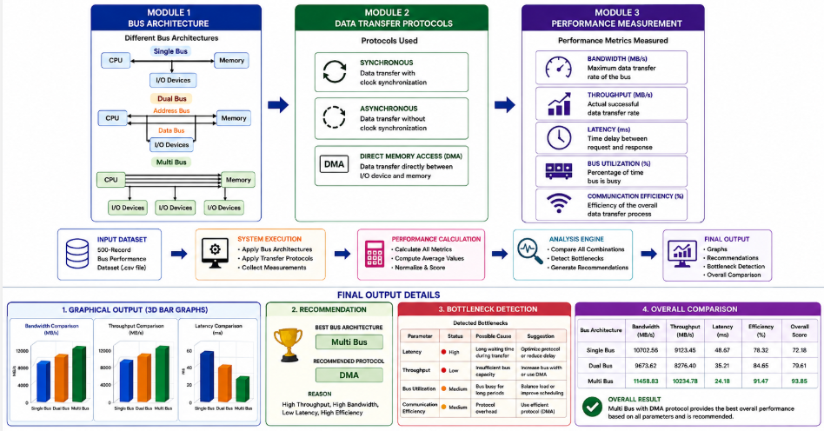
  - Trade-off Analysis

Design Decision | Alternative Considered | Benefit | Disadvantage | Final Decision
Dataset-based analysis | Manual calculation | Faster and reproducible | Depends on dataset quality | Selected
Python | Spreadsheet | More flexible automation | Requires programming | Selected
3D graphs | 2D graphs | Better visual presentation | More complex visualization | Selected
Modular implementation | Single large program | Easier maintenance and testing | Multiple files | Selected

  - Sustainability, Ethics, Safety, Risk & Security

Sustainability
This project does not depend on physical hardware implementation. The experimentation based on the dataset eliminates the requirement of physical testing and thus saves resources.

Ethics
Personal identifying information is not processed in this project.

Safety
As the project does not involve physical hardware implementation but is software based and uses offline dataset, there are no risks of safety involved.

Security
There is no requirement for the project to collect any sensitive user information.
Risk Register

Risk | Likelihood | Severity | Risk Level | Mitigation | Residual Risk
Dataset file not found | Medium | Medium | Medium | Verify file path | Low
Incorrect column names | Medium | Medium | Medium | Validate columns | Low
Invalid dataset values | Low | High | Medium | Data validation | Low
Python execution errors | Medium | Medium | Medium | Debugging/testing | Low
Incorrect calculations | Low | High | Medium | Cross-check results | Low
Graph readability issues | Medium | Low | Low | Adjust graph layout | Low

CHAPTER 4

IMPLEMENTATION, TESTING & RESULTS, PROJECT MANAGEMENT

  - Development Approach & Resources

It is important to note that the software was developed using a modular implementation approach based on the Python programming language. The core modules were developed as separate programs using the Python programming language and linked via the performance dataset. Pandas library was applied for data processing and calculation, while Matplotlib and NumPy were applied for visualizing results.
  - Hardware / Software / Fabrication Implementation & Modern Tools Used

Tool / Software | Purpose | Stage
Python | Core implementation | Development
Pandas | Dataset processing | All modules
NumPy | Numerical operations | Graph generation
Matplotlib | 3D graph generation | Results
CSV Dataset | Performance input | All modules
VS Code / PowerShell | Program development and execution | Development

  - Test Plan & Verification

Requirement | Test Method | Acceptance Criterion
Dataset loading | Execute Python program | Dataset loads successfully
Bus analysis | Enter each bus type | Correct values displayed
Protocol analysis | Enter each protocol | Correct protocol results displayed
Performance measurement | Enter bus type | Performance report generated
Graph generation | Execute graph program | 3D graphs generated
Bottleneck detection | Analyze performance metrics | Bottleneck reported
Recommendation | Compare performance | Recommended architecture displayed

  - Results

Module 1 – Bus Architecture
The module analyzes the three bus architectures using dataset-derived values.
For example, your Multi Bus output:
Parameter | Multi Bus Result
Total Records | 181
Average Bus Width | 57.10 bits
Average Clock Speed | 184.81 MHz
Average Bandwidth | 10788.95 MB/s
Average Bus Utilization | 13.88%

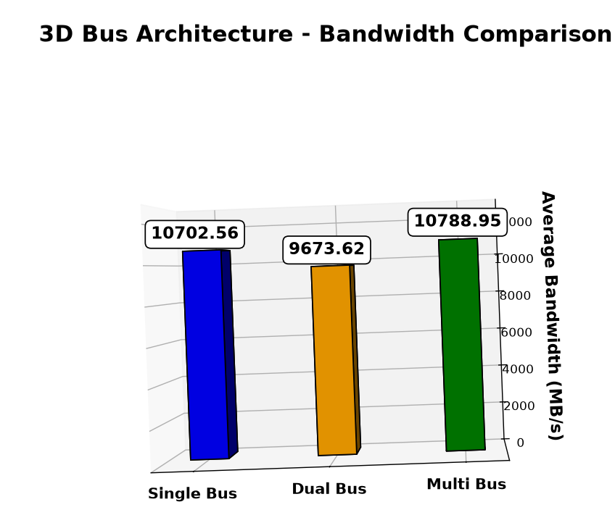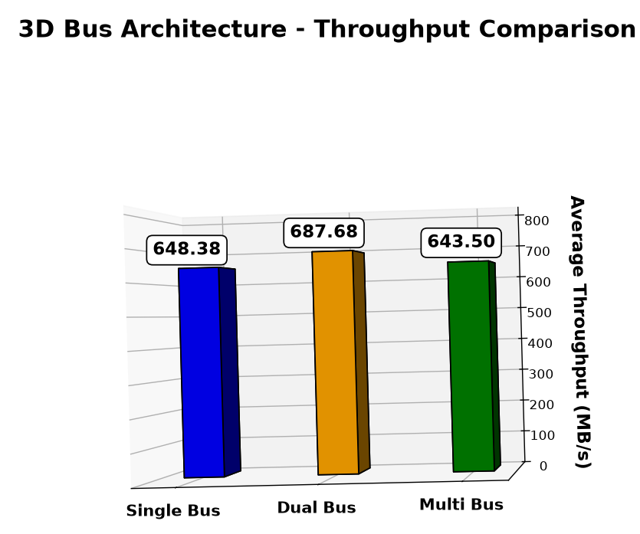

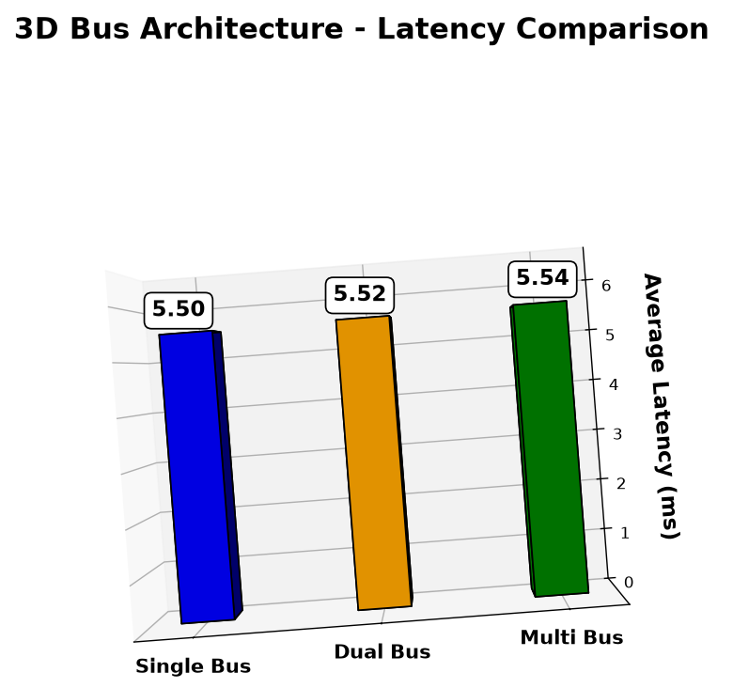
  - Data Analysis & Engineering Judgment
In the analysis, the performance of bus architecture cannot be measured with just one factor. The bandwidth is a measure of the theoretical capability to transfer data, but throughput is a measure of the actual amount of data transferred. Latency is a measure of the delay in communicating, and bus utilization is a measure of how well the bus capability is used.

The Multi Bus architecture has the highest performance among those tested because of its ability to communicate in parallel for better data transfer performance. But the decision is made after evaluating all the criteria and not just the bandwidth.
  - Comparison with Existing Solutions & Achievement of Objectives

Objective | Evidence | Achievement
Implement bus architecture analysis | Module 1 output | Fully
Evaluate data-transfer protocols | Module 2 output | Fully
Measure performance | Module 3 output | Fully
Generate graphical results | 3D bar graphs | Fully
Identify bottlenecks | Bottleneck analysis | Fully
Recommend suitable architecture | Final comparison | Fully

  - Strengths & Limitations
Advantages
- Performance evaluation based on datasets.

- Modular Python implementation.

- Three bus topologies are supported.

- Three transfer protocols are supported.

- Several performance measures.

- Graphical visualization is automated.

- Bottleneck detection.

- Architecture recommendation.

Disadvantages
- The accuracy of the results depends on the quality of the dataset used.

- No hardware implementation.

- No real-time monitoring of the buses.

- The performance results reflect the dataset provided and not the actual computer system.

- The recommendation logic can be enhanced using more advanced algorithms.
  - Project Planning, Roles & Budget

Student | Assigned Responsibility | Actual Contribution
Muthupriya R | Module implementation | Implemented three core modules, dataset processing, testing and graphs
Nethra M | System design and architecture | Architecture and system-level documentation
Rithika G | Analysis and comparison | Performance comparison, bottleneck and recommendation analysis

CHAPTER 5

CONCLUSION, FUTURE WORK AND REFLECTION

  - Conclusion
The project successfully designed the Bus Performance Evaluation System using data to analyze the performance of Single Bus, Dual Bus and Multi Bus architectures. There are three main modules in the system; Bus Architecture, Data Transfer Protocols and Performance Measurement. The system was able to process the dataset that consists of 500 records and measure the following performance parameters; bandwidth, throughput, latency, bus utilization and communication efficiency.

Outputs of the implementation include 3D graph report for performance of the buses, bottleneck analysis, architecture recommendation and general comparison. This gives the approach of analyzing the performance of buses based on the whole parameters not only one parameter.

From the performance analysis performed by the implementation, Multi Bus architecture has the highest performance out of all the architectures considered. Since Multi Bus architecture is able to perform parallel communication, this gives it the edge in data transfer performance. Hence, in the conditions of this project, Multi Bus architecture is recommended.
  - Future Work
Real-time monitoring: Integrate the system with real hardware/system-monitoring devices to collect real-time bus performance information.

Machine learning: Utilize machine learning techniques to predict the performance degradation and bottlenecks.

Advanced recommendation: Implement advanced recommendation algorithms based on workload type/system needs.

Interactive dashboard: Design an interactive dashboard in order to visualize the performance information in real time.

Hardware testing: Validate the findings using FPGA/processor-based hardware tests.

  - Professional Learning & Individual Reflection

Knowledge Gained
- Practical Python programming skills useful for engineering applications.

- Data-set manipulation techniques using Pandas.

- Calculation techniques of performance parameters statistics.

- 3D visualization using Matplotlib.

- Bus architecture understanding and data transfer methods.

- Engineering & Professional Skills Gained
- Python programming.

- Data set manipulation.

- Algorithm coding.

- Debugging and troubleshooting.

- Performance analysis.

- Documentation.

- Result analysis and visualization.

Individual Reflection – Muthupriya R
The main part that I contributed to the project is the development of the three core modules. I have coded the Python programs related to Bus Architecture, Data Transfer Protocols and Performance Measurement modules and also manipulated the 500 record data set with the implementation. The difficulty that I faced while working on this project is the handling of dataset path, column names, and obtaining of calculated values from the dataset.

REFERENCES
- T. Benz et al., “A High-Performance, Energy-Efficient Modular DMA Engine Architecture,” IEEE Transactions on Computers, vol. 73, no. 1, pp. 263–277, 2024.
- J. Zhu, L. Wang, L. Xiao, and G. Qin, “uDMA: An Efficient User-Level DMA for NVMe SSDs,” Applied Sciences, vol. 13, no. 2, p. 960, 2023.
- Ruzhanskaia, P. Xu, D. Cock, and T. Roscoe, “Rethinking Programmed I/O for Fast Devices, Cheap Cores, and Coherent Interconnects,” arXiv preprint, 2024.
- S. Mahar, H. Wang, W. Shu, and A. Dhanotia, “Workload Behavior Driven Memory Subsystem Design for Hyperscale,” arXiv preprint, 2023.
- Cho, A. Saxena, M. Qureshi, and A. Daglis, “A Case for CXL-Centric Server Processors,” arXiv preprint, 2023.
- Z. Liu, Y. Li, and X. Zeng, “ADPO: Adaptive DRAM Controller for Performance Optimization,” Micromachines, vol. 16, no. 4, p. 409, 2025.
- F. Cheng et al., “Ecco: Improving Memory Bandwidth and Capacity for LLMs via Entropy-Aware Cache Compression,” in Proc. International Symposium on Computer Architecture (ISCA), pp. 793–807, 2025.
- H. Park et al., “Capacity-Latency Tradeoffs in CXL Memory Expander at Hyperscale,” IEEE Computer Architecture Letters, vol. 25, no. 1, pp. 122–125, 2026.
- D. Gajaria et al., “An Integrated Framework for Memory-Centric Analysis: From Trace Collection to Co-Design,” Frontiers in High Performance Computing, vol. 4, 2026.
- Z. Xu, D.-L. Zhang, and Y. Song, “A High-Efficiency DMA Architecture for Fine-Grained Data Transfers,” in Proc. 11th International Conference on Computer and Communication Systems (ICCCS), pp. 346–352, 2026.

APPENDICES
Appendix A – Detailed Calculations
Include calculations for:
- Bandwidth
- Throughput
- Latency
- Bus utilization
- Communication efficiency
- Performance score
Appendix B – Engineering Drawings / Schematics
Include:
- System architecture
- Workflow diagram
Appendix C – Source Code
Include:
- bus_architecture.py
- data_transfer.py
- performance.py
- graph.py
- bottleneck.py
- recommendation.py
- comparison.py
Appendix D – Dataset Information
Include:
- Dataset name
- Number of records: 500
- Column descriptions
- Sample records
Appendix E – Experimental / Raw Data
Include relevant dataset outputs and result screenshots.
Appendix J – Individual Contribution Evidence
For your contribution, include screenshots showing:
- bus_architecture.py execution
- data_transfer.py execution
- performance.py execution
- Dataset integration
- 3D graphs
- Bottleneck output
- Recommendation output
- Overall comparison output

CAPSTONE PROJECT OUTCOME MAPPING SHEET

To be completed by the department/faculty assessor.

Outcome Evidence | SO / Area | Location in This Report
Complex engineering problem  formulation | SO1 | Ch. 1, Ch. 2
Engineering design under constraints | SO2 | Ch. 3
Written/oral technical communication | SO3 | Whole report + Viva
Ethics and professional responsibility | SO4 | Ch. 3 (3.7)
Teamwork and leadership | SO5 | Ch. 4 (4.8)
Experimentation, analysis, engineering  judgment | SO6 | Ch. 4 (4.3–4.6)
Independent acquisition of new  knowledge | SO7 | Ch. 5 (5.3)
Standards | SO2 | Ch. 3 (3.2)
Sustainability and  societal/environmental impact | SO2/SO4 | Ch. 3 (3.7)
Risk assessment and mitigation | SO2/SO4 | Ch. 3 (3.7)
Security considerations | Relevant SO | Ch. 3 (3.7)
Integrated/system-level engineering | SO1/SO2 | Ch. 3 (3.5)
Project planning and management | SO5 | Ch. 4 (4.8)
Individual contribution | SO1–SO7 | Contribution Statement + Ch. 4  (4.8)

